Help Fiori – Como adicionar contador no tile ou bloco
Como adicionar um contador para aparecer no tile de um app fiori ?
1-Criar um serviço OData que retorne exatamente a estrutura abaixo:
Exemplo OData em CDS que chama classe abap p/ calcular a quantidade.
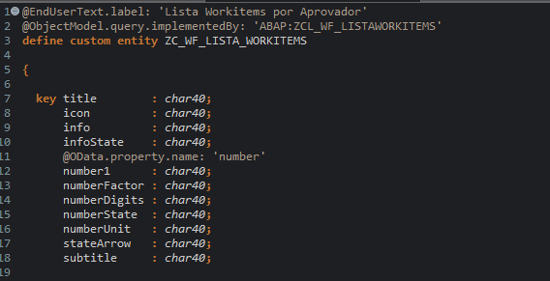

2-Criar uma classe e método que busque esta quantidade
Herdar a interface if_rap_query_provider

CLASS zcl_wf_listaworkitems DEFINITION
PUBLIC
FINAL
CREATE PUBLIC .

PUBLIC SECTION.

INTERFACES if_rap_query_provider .
PROTECTED SECTION.
PRIVATE SECTION.
ENDCLASS.

CLASS ZCL_WF_LISTAWORKITEMS IMPLEMENTATION.
METHOD if_rap_query_provider~select.

DATA: t_lista_wf TYPE TABLE OF zwfe0001,
t_sort_tab TYPE abap_sortorder_tab,
t_data_return TYPE STANDARD TABLE OF zc_wf_lista_workitems,
r_workflow TYPE RANGE OF zwfe0001-workflow.

IF io_request->is_data_requested( ) OR io_request->is_total_numb_of_rec_requested( ).

DATA(t_orderby) = io_request->get_sort_elements( ).

DATA(vl_top) = io_request->get_paging( )->get_page_size( ).
DATA(vl_offset) = io_request->get_paging( )->get_offset( ).
DATA(vl_conditions) = io_request->get_filter( )->get_as_sql_string( ).

IF vl_top = -1.
vl_top = 1.
ENDIF.

CALL FUNCTION 'ZWFF0001'
EXPORTING
i_usuario = sy-uname
* i_api =
IMPORTING
e_lista_wf = t_lista_wf.

IF io_request->is_data_requested( ).

REPLACE 'TITLE' IN vl_conditions WITH 'WORKFLOW'.

IF vl_conditions CP 'WORKFLOW =*'.
DATA(vl_wf) = vl_conditions+11.
SHIFT vl_wf LEFT DELETING LEADING ''''.
SHIFT vl_wf RIGHT DELETING TRAILING ''''.
CONDENSE vl_wf.

IF vl_wf EQ 'WS99900012'.
r_workflow = VALUE #( ( sign = 'I' option = 'EQ' low = 'WS99900012' )
( sign = 'I' option = 'EQ' low = 'WS99900013' ) ).

SELECT * FROM @t_lista_wf AS t_lista_wf_alias
WHERE workflow IN @r_workflow
ORDER BY workflow
INTO TABLE @DATA(t_lista_wf_lcl)
UP TO @vl_top ROWS OFFSET @vl_offset.
ELSE.
SELECT * FROM @t_lista_wf AS t_lista_wf_alias
WHERE (vl_conditions)
ORDER BY workflow
INTO TABLE @t_lista_wf_lcl
UP TO @vl_top ROWS OFFSET @vl_offset.
ENDIF.

ENDIF.

IF t_lista_wf_lcl IS NOT INITIAL.

t_data_return = VALUE #( FOR ls_lista_wf_lcl IN t_lista_wf_lcl
( icon = 'sap-icon://complete'
infostate = 'Critical'
number1 = |{ ls_lista_wf_lcl-quantidade ALPHA = OUT }|
numberdigits = '1'
* numberfactor = 'K'
numberstate = 'Positive'
numberunit = 'UN'
subtitle = 'Aprovação Workflow' ) ).

IF t_orderby IS INITIAL.
t_sort_tab = VALUE #( ( name = 'TITLE' ) ).
ELSE.

LOOP AT t_orderby ASSIGNING FIELD-SYMBOL(<fs_ordeby>).
APPEND VALUE #( name = <fs_ordeby>-element_name
descending = <fs_ordeby>-descending ) TO t_sort_tab.
ENDLOOP.

ENDIF.

SORT t_data_return BY (t_sort_tab).
io_response->set_data( t_data_return ).

ENDIF.

IF t_data_return IS INITIAL.

t_data_return = VALUE #( ( icon = 'sap-icon://complete'
infostate = 'Critical'
number1 = '0'
numberdigits = '1'
* numberfactor = 'K'
* numberstate = 'Neutral'
* numberunit = 'UN'
subtitle = 'Aprovação Workflow' ) ).
io_response->set_data( t_data_return ).
ENDIF.

IF io_request->is_total_numb_of_rec_requested( ).
io_response->set_total_number_of_records( lines( t_data_return ) ).
ENDIF.
ENDIF.

ENDIF.

ENDMETHOD.
ENDCLASS.

3-indicar o serviço no tile
